FINAL EXAM PAPER
Quarter: 3 - Academic year: 2023 – 2024
School of Computing Information Technology
Course code: CSE 202 |  | Exam code: 01
Course name: Discrete Math 2 |  | Duration: 120’
Type of Exam: Closed book / Practice on Computer |  | Maximum mark: 100

Instructions:
- Non-programming calculator: Yes ☑ | No ◻
- This paper consists of 2 sections. This paper carries 100 marks
Section 1 (20 marks) includes 4 questions. Each question carries 5 marks.
Section 2 (80 marks) includes 3 questions. Questions 1 carries 30 marks, question 2 carries 30 marks and, question 3 carries 20 marks
------------------------------------------------------------------------------------------------------------------------------
SECTION 1
Question 1 (5 marks)
What is a complete graph, a bipartite graph, a tree, a binary search tree, and a spanning tree?
Question 2 (5 marks)
Prove that the number of vertices with odd degree is always even
Question 3 (5 marks)
Find the shortest path from 0 to other vertices using Dijkstra algorithm.
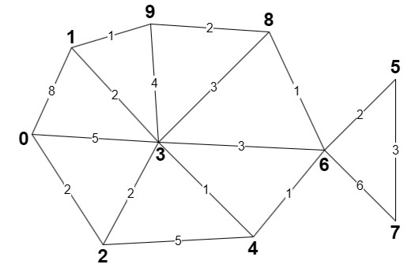
Question 4 (5 marks)
Draw the binary search tree if its nodes are inserted in the following order
22 19 30 34 17 25 37 4 9 11 31 1
SECTION 2
Question 1: BREADTH-FIRST SEARCH (30 marks)
Given a directed graph, print the order of visiting vertices using the Breadth-First Search algorithm starting from vertex 0, with larger vertices prioritized over smaller ones.
Input
- The first line consists of two positive integers, the number of vertices n (0 < n <10⁵) and the number of edges m (0 < m < 2x10⁵).
- Then there are m lines, each containing two integers u and v (u, v < 10⁵), representing the direction from u to v.
Output
The list of vertices in the required order, separated by spaces.
Example
Input:
Input | Output
4 4  0 3  3 2  1 0  0 1 | 0 3 1 2
Question 2: COUNT VERTICES (30 marks)
You are provided with a tree consisting of 𝑁 vertices connected by 𝑁−1 edges, with vertex 1 as the root. Each edge has an associated weight, and each vertex has a weight as well. Your task is to count the number of vertices (excluding the root) whose weight does not exceed the weight of any edge in their path from the root vertex.
Input
An integer 𝑁 (the number of vertices in the tree, 1 ≤ 𝑁 ≤ 100,000).
A sequence of 𝑁 integers representing the weight for each vertex.
𝑁−1 subsequent lines, each containing three integers 𝑢, 𝑣, and 𝑤, indicating an edge with weight 𝑤 connecting vertex 𝑢 and vertex 𝑣.
Output
An integer representing the number of vertices whose weights do not exceed the weights of any edge in their path from the root.
Example
Input | Output
5  8 11 15 20 9  1 2 10  1 3 15  2 4 20  2 5 10 | 2

Question 3: NETWORK DELAY TIME (20 marks)
You are given a network of n nodes, labeled from 1 to n. You are also given times, a list of travel times as directed edges times[i] = (u_{i}, v_{i}, w_{i}), where u_{i} is the source node, v_{i} is the target node, and w_{i} is the time it takes for a signal to travel from source to target.
We will send a signal from a given node k. Return the minimum time it takes for all the n nodes to receive the signal. If it is impossible for all the n nodes to receive the signal, return -1.
Input
- The first line contains three integers n – number of nodes, k - starting node, m – list of travel time’s size.
- In the next m lines, each line contains 3 integers u, v, w is the information of time.
Output
The minimum time it takes for all the nodes receives the signal.
Example
Input | Output
4 2 3  2 1 1  2 3 1  3 4 1 | 2
2 2 1  1 2 1 | -1
------ End ------
Lecturer
Lecturer’s signature

Nguyễn Mạnh Phúc

